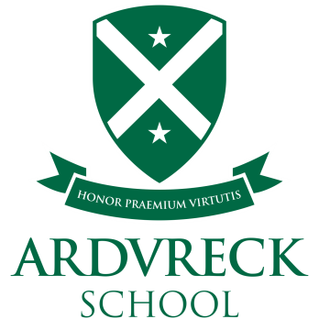

Our catering service has a procedure where we aim to cater for pupils who have special diets for medical reasons.
The 14 most common food allergens (identified by the European Union) are:
- celery
- cereals containing gluten (including wheat, oats, barley and rye)
- crustaceans
- eggs (including hen, duck, etc.)
- fish
- lupin
- milk (including cows, goats, sheep, etc.)
- molluscs
- mustard
- nuts (including almond, hazelnut, walnut, cashew, pecan, brazil, etc.)
- peanuts
- sesame
- soya
- sulphur dioxide (above 10mg/kg in the finished product)
If you need to register your child as having a special diet then please contact our school office for a point of contact. In addition to medical requirements, the special diet process covers vegan diets and diets for religious reasons.
Ardvreck School & Nursery, have menus for gluten, egg and dairy free pupils who have been registered as receiving a special diet. Allergen information for the current menu are also available.
We offer a choice of menus per term, operating on a three-week cycle and served with a selection of healthy side dishes, bread and a well-stocked salad bar.

